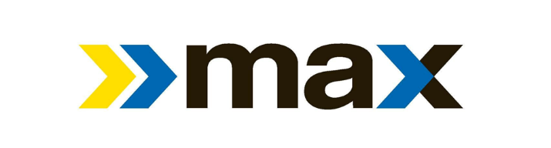

Birmingham-Jefferson County Transit Authority
Commemorates National Get On Board Day with Free Rides
National Get On Board Day will be held on April 25, 2019.

Birmingham, AL (April 23, 2019) The Birmingham-Jefferson County Transit Authority (BJCTA) will join with other public transportation systems nationwide to participate in National Get On Board Day on Thursday, April 25th. The BJCTA will commemorate the value and benefit of public transit on National Get On Board Day by providing free transportation all day long to every rider.
Governor Kay Ivey proclaimed April 25th as Get On Board Day. Additionally, the mayors of Birmingham, Homewood, Hoover, Mountain Brook, Tarrant and Vestavia have all proclaimed April 25th as Get On Board Day in their respective cities to support this national advocacy day.
Sponsored by the American Public Transportation Association (APTA), National Get On Board Day is a day set aside to encourage people to support and utilize public transportation. It also showcases the benefits public transportation brings to communities. Each weekday in the U.S., 34 million people board public transportation and can be a gateway to prosperity, education and opportunity. It transforms communities and people by encouraging economic development. For every dollar invested in public transportation, it generates four dollars in economic returns.
Frank T. Martin, Interim Executive Director of the BJCTA, shared that this day will provide an opportunity for new riders to experience the value, safety and savings of public transportation. “Support from the mayors of Jefferson County has been incredible. The transit authority values the relationship with our partner cities, and we want to continue to provide exceptional service to those residents.”
By utilizing public transportation, riders support a greener environment. Communities that invest in public transit reduce the nation’s carbon emissions by 37 million metric tons annually and the overall effects save the United States 4.2 billion gallons of gasoline annually.
Not only does transportation through the BJCTA provide economic value and encourages a more environmentally friendly way to travel, it’s also a safer way to travel. For those traveling by public transportation, they are 10 times safer per mile than traveling by automobile and a person can reduce his or her chance of being in an accident by more than 90 percent by taking public transportation.
For more information on how to coordinate your travel through the BJCTA during National Get On Board Day, please visit https://maxtransit.org/ and plan your trip.

