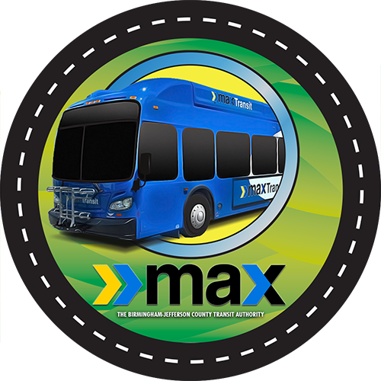

On Saturday night, October 20th, at approximately 10:12 p.m.., an altercation between two passengers occurred on a MAX bus at the intersection of Center Point Parkway and Huffman Road. The Birmingham Police are currently investigating. The bus has been taken out of service to allow the Birmingham Police to inspect as part of their investigation. No other passengers were involved.

