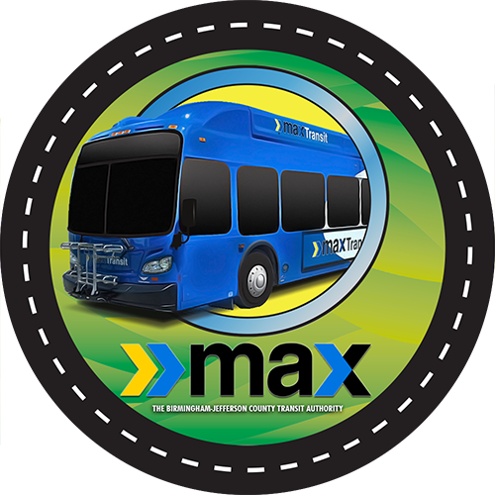

This morning, between 10:00 and 10:15 a.m., an accident occurred in Birmingham at the intersection of Carson Road and 6th Avenue NW, involving a MAX bus. On board were six passengers and the driver. Three passengers were transported to the hospital. At this time, the MAX safety department is on the scene investigating. At its conclusion and as more facts become available, we will make them known.

