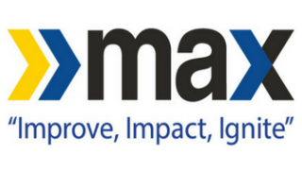
For more information, contact:
Becci Hart
Intermark Public Relations
205.936.0707
Or
Lauren Bland
Intermark Public Relations
407.256.0008

BJCTA Donates MAX Bus to Lawson State Community College
Transit authority helps further hands-on experience for students enrolled
in Lawson State Community College’s diesel mechanic program with donation.

Birmingham, AL (November 9, 2018) – Birmingham Jefferson County Transit Authority (BJCTA) is pleased to announce the donation of a MAX bus to Lawson State Community College. The donation of the decommissioned bus will benefit the college’s Alabama Center for Automotive Excellence (ACAE) program. The program is offered to those interested in working as mechanical technicians in the transportation service.
“Giving students hands-on experience through the donation of one of our buses showcases the commitment of the BJCTA to the citizens of Birmingham. To their educational opportunities and economic prosperity. The necessary training for future diesel mechanic is invaluable, particularly for the transit authority. We look forward to seeing graduates of this program working with MAX in the near future,” shared Christopher Ruffin, Interim Executive Director of the BJCTA.
BJCTA recognizes the increasing demand for diesel mechanics in the transportation industry and the increasing need for trained mechanics to keep MAX buses on the roads.
“Between 2016 and 2026, the Bureau of Labor Statistics projects employment in the automotive service industry will expand 6 percent, which will result in 47,600 new jobs. Job placement for the program is 100%. We hope to prepare our students for a successful career in this industry and thank the BJCTA for their efforts in furthering that education,” says Dr. Perry W. Ward, Lawson State Community College president.
The keys were passed from Interim Executive Director Ruffin to Lawson State Community College President on Friday, November 9th at the Intermodal Facility Bus Terminal where the bus will be transferred to the campus.
###

