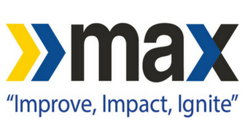
For Immediate Release:
For more information, contact:
Becci Hart or Lauren Bland
Intermark Group
205.803.0000

BEST MAX BUS DRIVER ANNOUNCED AT OTHER AWARDS

Birmingham Voted Online and during National Get On Board Day

Birmingham, AL (May 15, 2019). – Winners of The Other Awards were announced last night, including Best MAX Bus Driver, Ms. Nioka (CoCo) Boyce. The Other Awards were created to honor those in our community who are often the unsung hero, those doing great things but receiving no recognition.

The awards were based on online nominations and votes cast by riders at MAX’s Central Station on National Get On Board Day. Other categories included Birmingham Cheerleader, Favorite Birmingham City School Teacher, Funniest Person and Favorite Service Industry Worker (barista, bus boy, server, kitchen staff, bartender, etc.)

“We aren’t surprised that our riders chose Ms. Boyce,” said XXX. “People always stop her when she is walking through Central Station with a friendly greeting and it is obvious she is very well liked and respected.”

Ms. Boyce has been driving for the Birmingham-Jefferson County Transit Authority for almost three and a half years. She is currently driving buses on a range of routes including the #12, #18, #25, #26 and the 280 route.

“My philosophy has always been that doing what’s right is right, just not always easy,” Ms. Boyce offered. “It is important to me that I try to notice things about people as individuals, find a way to encourage or lift them up. Our drivers are the face of the BJCTA, the first and last person a rider sees when they ride our buses. We have the ability to genuinely impact their day and I take that seriously.”

